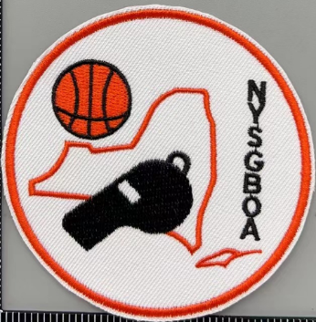
NYSGBOA, Inc.

Thank you for your interest in rules courses offered by New York State Girls Basketball Officials Association (NYSGBOA) & International Association of Approved Basketball Officials (IAABO), the premier basketball officiating organization in the world!
The cost for the course is $50. Once you’ve paid, you will be able to access the course immediately with the username and password you set up during registration. You can go through the material at your own pace, as you have time. From the time you enroll, you will have 90 days to complete the course and successfully pass the 50-question NYSGBOA/IAABO candidate exam.

A full, detailed description of the course, its structure, and test requirements are included on the first page once you access the IAABO University platform. If you have any questions about course content or rules, Louis (Louie) Stellato @ louie1157@gmail.com. If you have technical issues, please contact Joe Gabriel at joe.gabriel@comcast.net

The course is comprised of eight straightforward and easy-to-follow classes. After you’ve reviewed the slides in a class, there is a quiz to take. Once you are confident with the material covered in that lesson, move on to the next one until you complete the course. A downloadable/printable student manual with all lesson quizzes, practice tests and other helpful information will also be provided once you pay for the course.
Passing the rules certification exam is only the first step in becoming an NYSGBOA member. After passing the rules certification exam, a local board representative will advise you of any additional costs to prepare you for floor training. Once you’ve successfully completed the floor training, a local board representative will inform you of the specific requirements for becoming a registered member of NYSGBOA.
We do not recommend that you officiate any games until you are a member of the local NYSGBOA board. The certification process is not complete until you’ve completed all of the necessary steps; NYSGBOA University is just the first step. Please understand that until you become a registered member of NYSGBOA, you do not have general liability insurance coverage and would be putting yourself at risk if you officiate games. New York State Education requires new officials to be fingerprinted. (See information regarding fingerprinting below)

NYSGBOA, in conjunction with The Sports Loft & Purchase Officials have put together a starter package for your uniform needs. Upon successful completion of this course, you can order your uniform by clicking on the following link - https://purchaseofficials.com/collections/nysgboa
Now that we’ve gotten the formalities out of the way, are you interested in taking the first step to start earning some extra money in one of the best part-time avocations you will ever have? If you are ready to get started, please click on the link below to purchase the course. The materials will then be forwarded to you.
Below, you will find the link to sign up. Once we receive your payment, you will receive an email with instructions on how to access the course.
To register for the New York State High School Girls course – click here: https://courses-iaabou.org/new-york-state-high-school-girls/

If you have any questions or concerns related to IAABO University please contact Donnie Eppley @ deppley@iaabo.org or for the NYSGBOA University, please contact Louis (Louie) Stellato @ louie1157@gmail.com

Fingerprinting Information -

TEACH/Fingerprinting Procedures for Officials
All sports officials are required to be fingerprinted. Assignors may only assign officials who have been fingerprinted, cleared per New York State Education Department (NYSED and are listed on the database as a cleared official.
Steps:
1. Sports officials must first establish a TEACH account through the New York State Education Department's TEACH Online Services System.
Click on the link or go to: www.highered.nysed.gov/tcert/teach/
In the bottom left-hand corner, “create a TEACH account. Be sure to create this account prior to getting prints done.
2. Fingerprinting is done through MorphoTrust [(877) 472-6915], a statewide
vendor managed system. To find locations and schedule an appointment,
go to: www.identogo.com and click on Get Fingerprinted >State of New York >Digital Fingerprinting. The next screen is where you enter a code.
3. The MorphoTrust system will ask for a Service Code. NYSED uses a code (which is easier to remember) rather than a number. The NYSED code is: TEACH but it will not work!!
TEACH
4. When you enter TEACH into the above screen, it does not work. Click on the “click here” button below the TEACH box to proceed.
5. The next screen will ask you for your state again (NY); your ORI Number (TEACH) and your reason for fingerprinting (EMPLOYEE APPLICANT). Once this info is
submitted, you will get the following screen:
6. Once you hit continue, you will get the following screen:
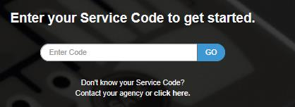

Use Code below if desired


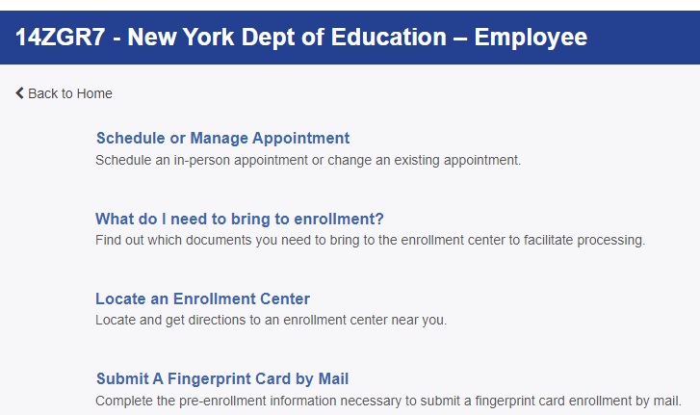
7. Schedule your appointment
8. Once an official has been fingerprinted. They should contact the Section office in thier region. Please use this link to determine what Section you are located in and how to contact the Section Office. The Section Office will direct you on how to proceed.
a. Section Map: https://nysphsaa.org/sports/2021/6/7/section-map.aspx
9. If an official's fingerprint clearance is denied by the NYSED, that official will be made inactive until the official files the appeal, the case is reviewed, and the official is cleared. An official may call their Section office for the contact information of the OSPRA office.
10. Any subsequent arrest notices, after an official has been cleared, will be sent from NYSED to the appropriate parties and the official. The official will be notified by certified letter and will forward the notices to their Section office. The official will be made INACTIVE immediately. Any official that is arrested is responsible for contacting both the NYSED Office of School Personnel Review and Accountability at (518) 473-2998 as well as any other appropriate parties to resolve the situation prior to any more contests being assigned.

